ADARSH PRATISHTHAN
REPORT FOR OCT-NOV-DECEMBER 2021
This has been a lean time for us mainly because of the strike by State Transport Workers. The fare for private vehicles has shot up fourfold. We hope the situation improves in this quarter.
- The total number of admissions were: 33
October: 8 November: 20 December: 5
- Follow up patients : 100
October: 41 November: 29 December: 30
Out of these there were 15 were with Severe Acute Malnutrition [S.A.M.]
17 children had Moderate Acute Malnutrition.
Three children were positive for Sickle Cell Anemia and
7 children needed blood transfusion.
As it was difficult for patients to reach us, we decided to go to them. Accordingly, we held TWO CAMPS during this period and examined a total number of 122 patients.
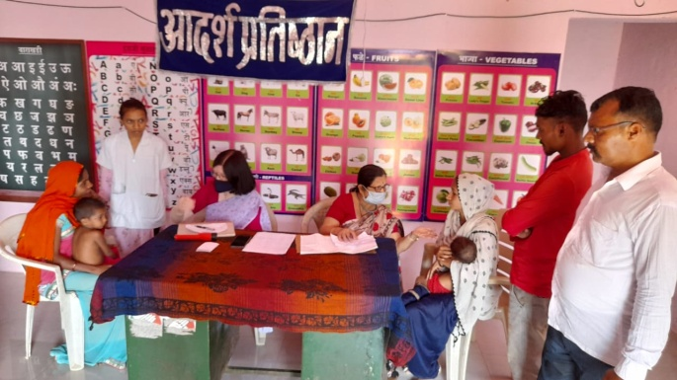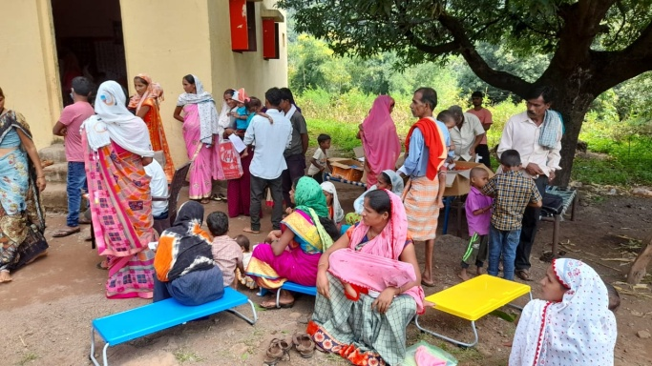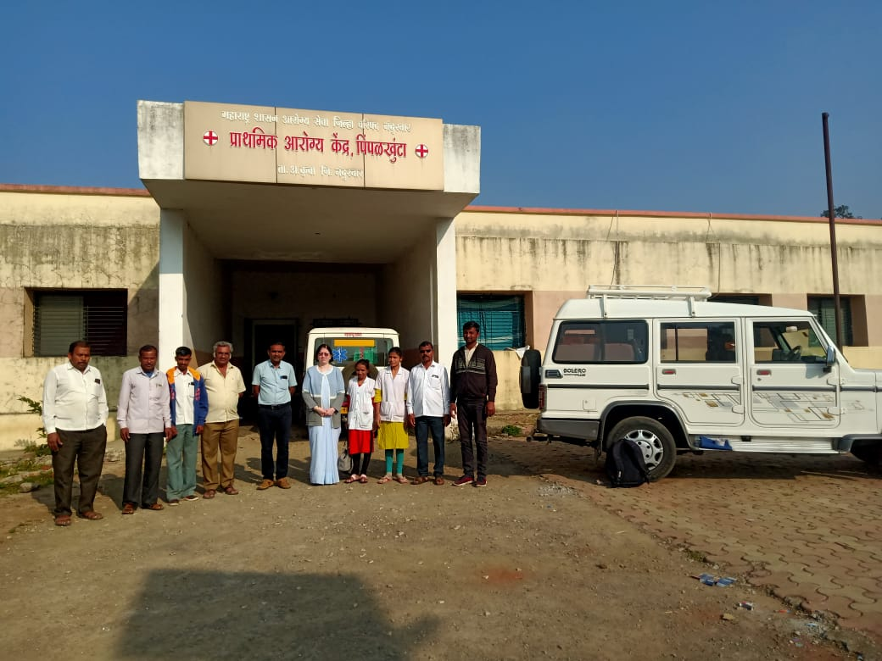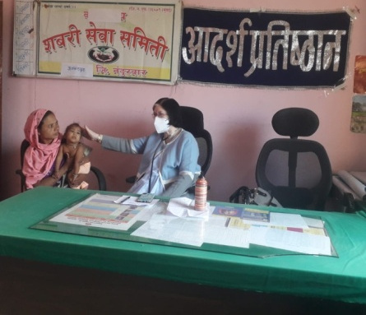
Although we have advised admissions for sixty of these patients, their parents are unable to comply. The main reasons are:
[1] Lack of funds [2] Parents Migration to Gujrat as labourers
So, our social workers paid HOME VISITS. The places they visited were
[1] Somana [2] Khuntamoli [3] Khaligavhan [4] Kundal [5] Surwani
[6] Khandbara [7] Varkhedi
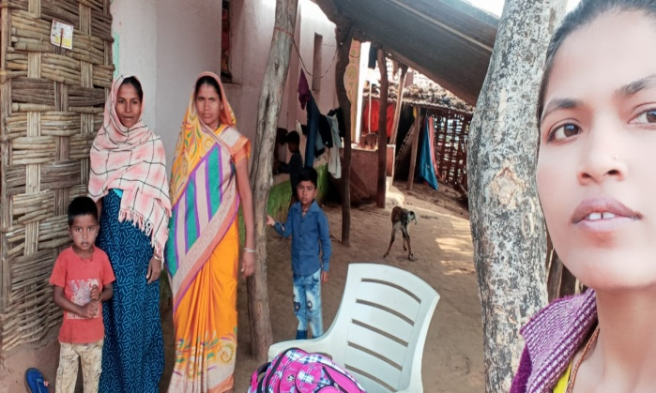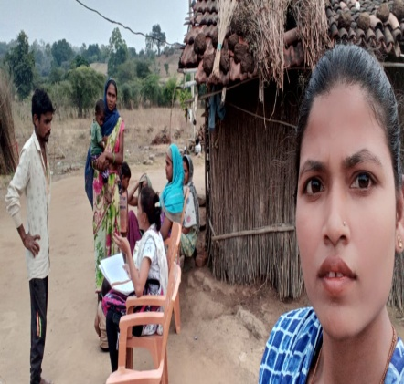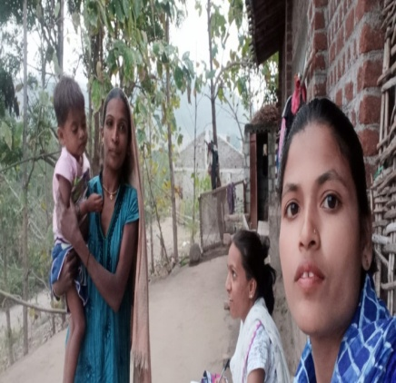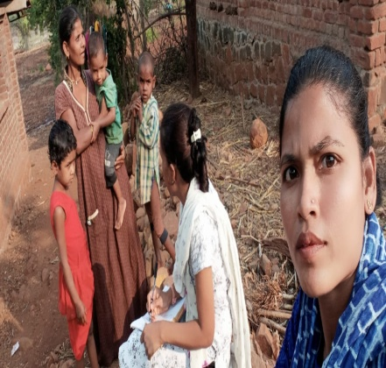
They found that reasons for patient default in follow-up visits were manifold.
[1] Lack of funds
[2] Male members of family were away in another state.
[3] Did not realize that they were called for a follow up visit.
[4] Alcoholic father refused further treatment, wanted to be left to fate.
[4] Some felt that their children had put on adequate weight and did not need further treatment.
TWO patients had expired. One due to CONGENITAL HEART DISEASE COMPLICATIONS. The other had a blood transfusion in Nandurbar Civil Hospital and died of complications.
The lesson we have learnt is that we need to reach out more, and maybe provide free transport which at present we are unable to provide. We will do so in future if sufficient funds are available in near future.

